SAP Notes

Abraham F

SAP FICo

FI ___________Finance (for Reporting Purpose mainly external)

CO__________Controlling (internal Reporting)

**Test The System**

Test Scripts

When creating fixed asset it throw this error

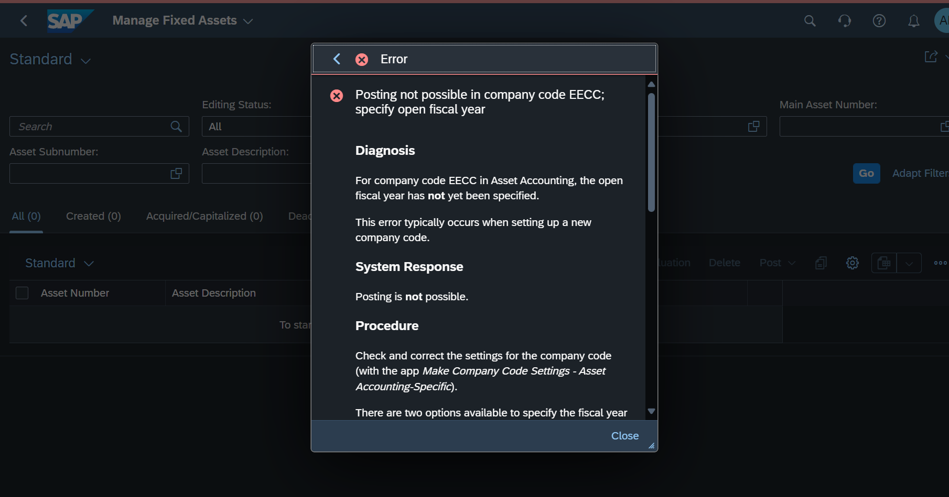

Compare Supplier Quotation is not working due to internal configuration issue

DAY 3